**Separating using crystallisation**

**Aim:** To separate a salt from water to using crystallisation.

**Materials:**

* 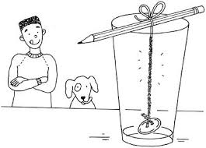Beaker
* Hot Water
* Food colouring
* Salt
* String
* Nail
* Spatula
* Stirring rod
* Wooden skewer
* Kettle
* Tape

**Method:**

1. Carefully put 60mL (¼ cup) of hot water from the kettle in the beaker.
2. Stir 3-4 drops of food colouring into the water.
3. Slowly add the salt one spoon at a time, stirring until each spoonful dissolves. Continue until no more salt dissolves into the water.
4. Tie the nail to the end of the piece of string and lower the nail into the salty water until it is on the bottom of the glass. Tie the string to the wooden skewer so it sits at the required height. (see top right image)
5. Lay the wooden skewer over the top of the glass and tape in place.
6. Leave the glass in a safe place for 2-4 days.

**Discussion:**

1. What type of mixture is the salt and water? How do you know?
2. Write 3 observations of your experiment from the first day.

1. Which substance is lost in this experiment? What could you do to try and keep it?
2. Write 3 observations of your experiment from the last day.

1. Describe a situation where this type of separation could be useful.